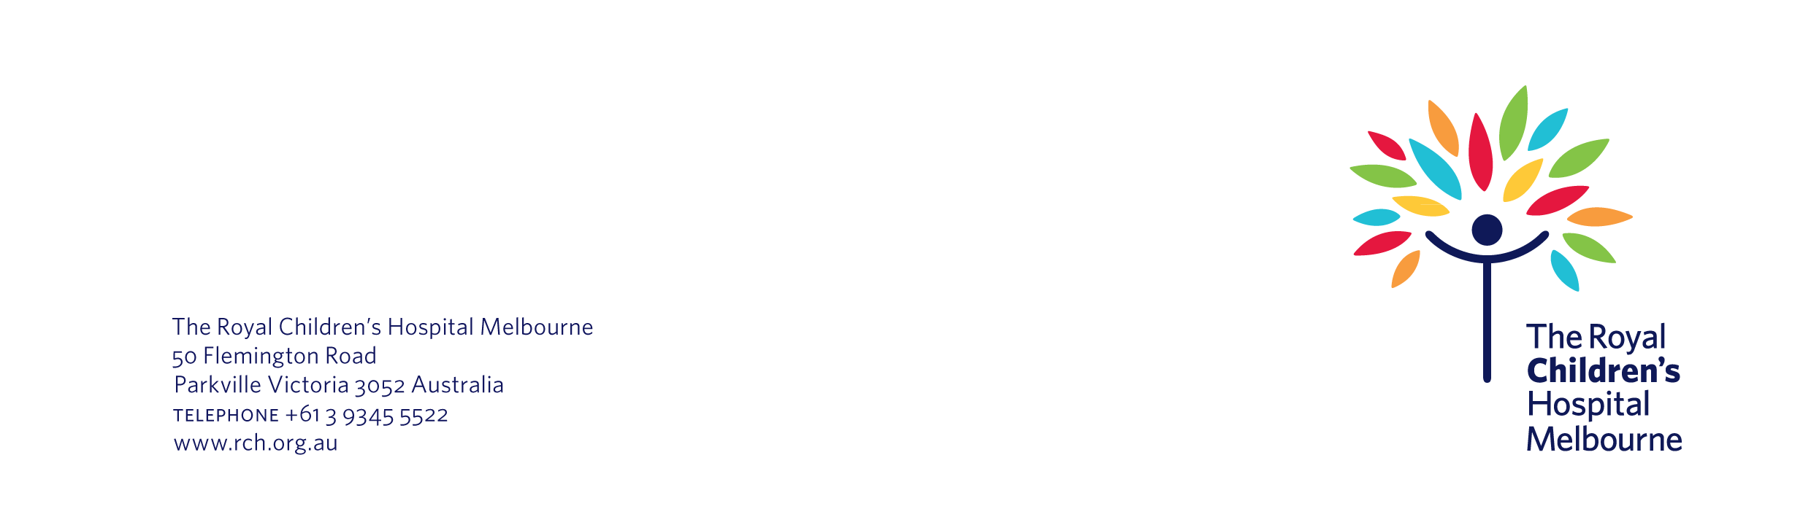
10 February 2021

Re: | The Healthy Baby study has now finished
Study number: | 12345

Dear Ms Cheng,

We are writing to let you know that the Healthy Baby study has finished. This study aimed to look at how COVID-19 affects newborn babies.

We have made the difficult decision to stop this study sooner than expected. As you would know, there are currently low rates of community transmission of COVID-19 in Victoria. This is, of course, welcome news. It also means that we cannot recruit enough newborn babies to participate in our study. Likewise, we cannot collect enough information to answer our research questions.

We apologise for any inconvenience we have caused you and your baby. We also confirm that you can stop filling in the electronic baby diary we gave you at the beginning of this study.

As agreed, we will keep the de-identified information you have already provided to us. This is because it may be useful to other researchers in the future. However, if you have any questions or concerns about this, please let us know. You can contact us by phone on (03) 9999 9999 or by email on covidbabies@rch.org.au.

Thank you for the time you and your baby have invested in this project. We are grateful for your support.

Yours sincerely,

Professor Rana Lowe and Associate Professor Andrew Adamos
Healthy Baby study team
The Royal Children’s Hospital

